Instructions for Conjuguemos:
Go to https://conjuguemos.com and sign up for an account.
- Your username should be your first name followed by your last name with a space in between. Ex: Lindy Findlen. Keep in mind that I can see your password. Please don’t pick anything that you don’t want me to see!
- Choose your school, class period, etc.

Your assignment:
There should be three visible activities after you log in:
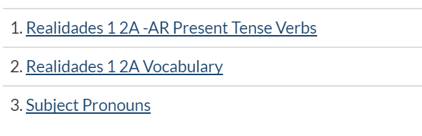
Activities 1 and 3 are required.

Instructions:
- Click on the assignment.
- Hit
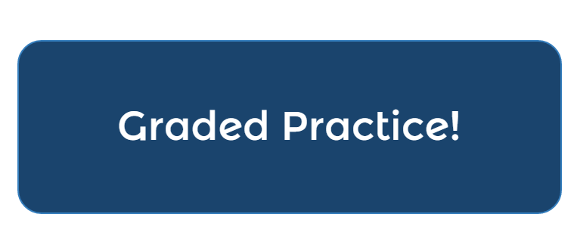
- Follow the instructions. You will receive a grade out of 10 points for each assignment. The percentage that you receive will be your grade for the assignment. You may start over as many times as you would like, but you must complete at least 30 verbs. When you are satisfied with your score, click RECORD SCORE and your score will be sent to me.
- After you have recoded activities 1 and 3, you may try out Realidades 1 2A Vocabulary and any other 2A games in conjuguemos. You can also try out the vocabulary games in Quizlet.

